**Project report**

**Group Members:**

Abubakar Waziri -4220056

Muhammad Alansari -4312897

**Overview**

We implement a simple shell command executor in C. It allows users to execute various shell commands, maintain a history of executed commands, and execute two commands simultaneously using the **join** command.

**Key Features**

1. **Command Execution**: Users can execute shell commands like **ls**, **pwd**, **whoami**, etc.
2. **Command History**: The shell maintains a history of the last 100 commands executed, which can be displayed or cleared.
3. **Join Command**: Users can execute two commands in simultaneously.
4. **Thread Safety**: The command history is protected with a mutex to ensure thread safety when accessed by multiple threads.

**Important Code Sections**

**Command Execution**

The main logic for executing commands is handled in the **run_command** function. This function uses **execvp** to execute commands passed as arguments.

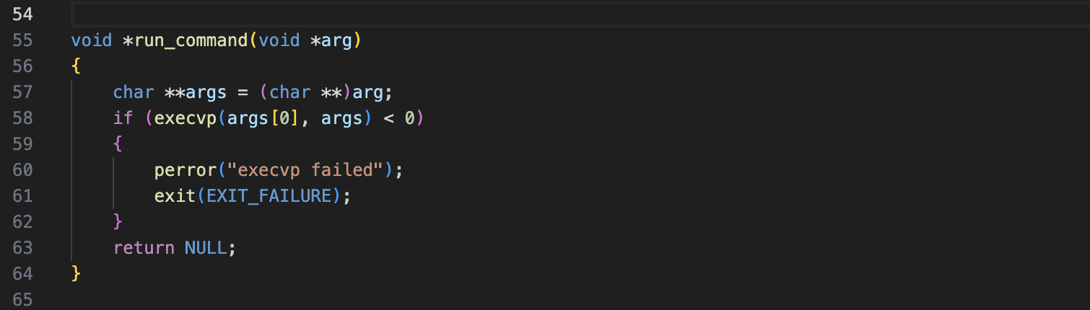

**Command History Management**

The command history is managed with a **mutex** to ensure that it is accessed safely in a multithreaded environment.

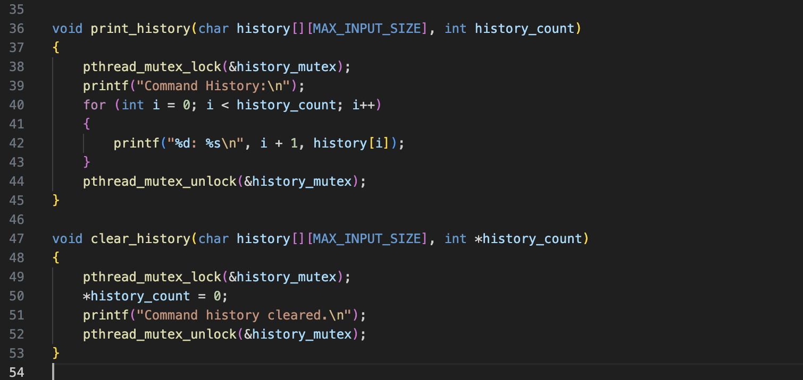

**Join Command Implementation**

The **join** command allows users to execute two commands concurrently. The implementation forks two processes, one for each command.:

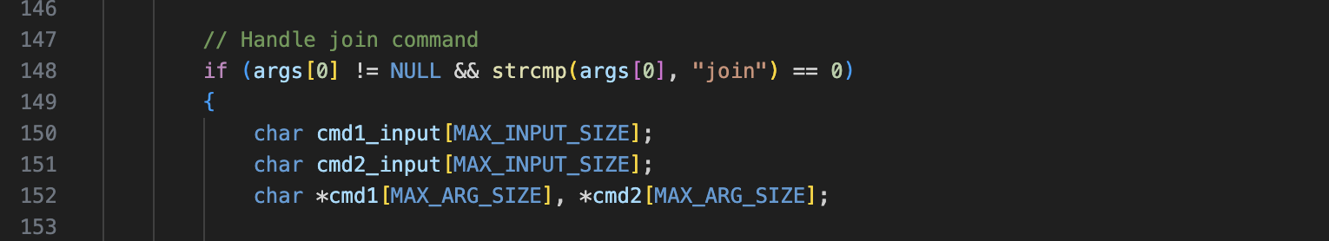

* **Condition Check**: The code first checks if the first argument (**args[0]**) is not **NULL** and if it equals **"join"**. *This determines if the user wants to execute the****join****command.*
* **Variable Declarations(characters)**: It declares variables to hold the input commands (**cmd1_input** and **cmd2_input**) and arrays to store the tokenized arguments for each command (**cmd1** and **cmd2**).

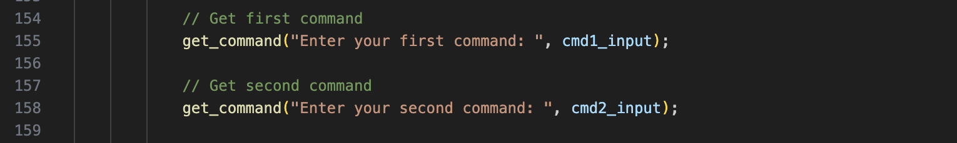

* **Get Commands**: The **get_command** function prompts the user to enter two commands. The first command is stored in **cmd1_input**, and the second in **cmd2_input**.

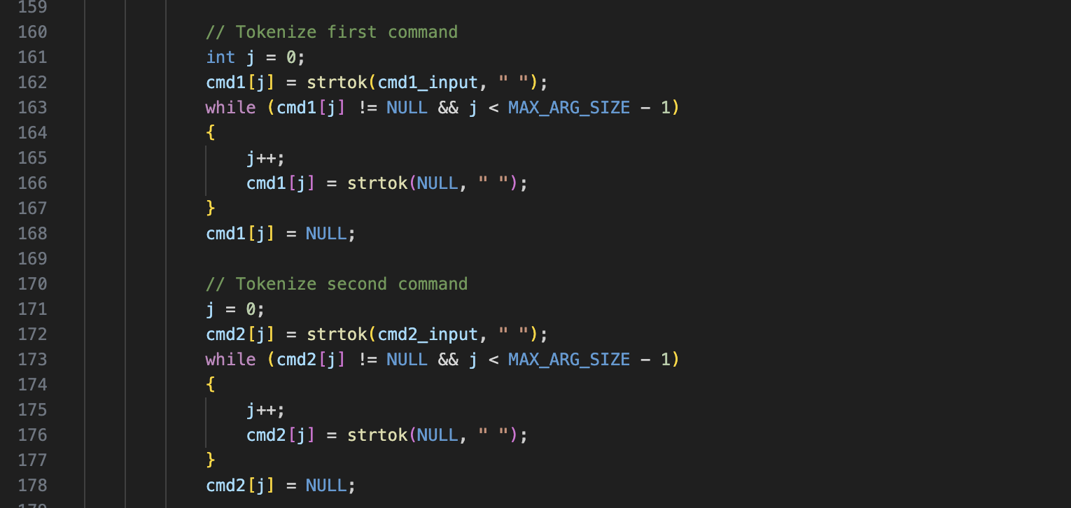

* **Tokenization of the First & Second Command**:
  + The **strtok** function is used to split **cmd1_input** into tokens based on spaces.
  + The first token is assigned to **cmd1[0]**, and subsequent tokens are assigned in the loop until there are no more tokens.
  + The last element of **cmd1** is set to **NULL**, which is necessary for the **execvp** function to know where the argument list ends.

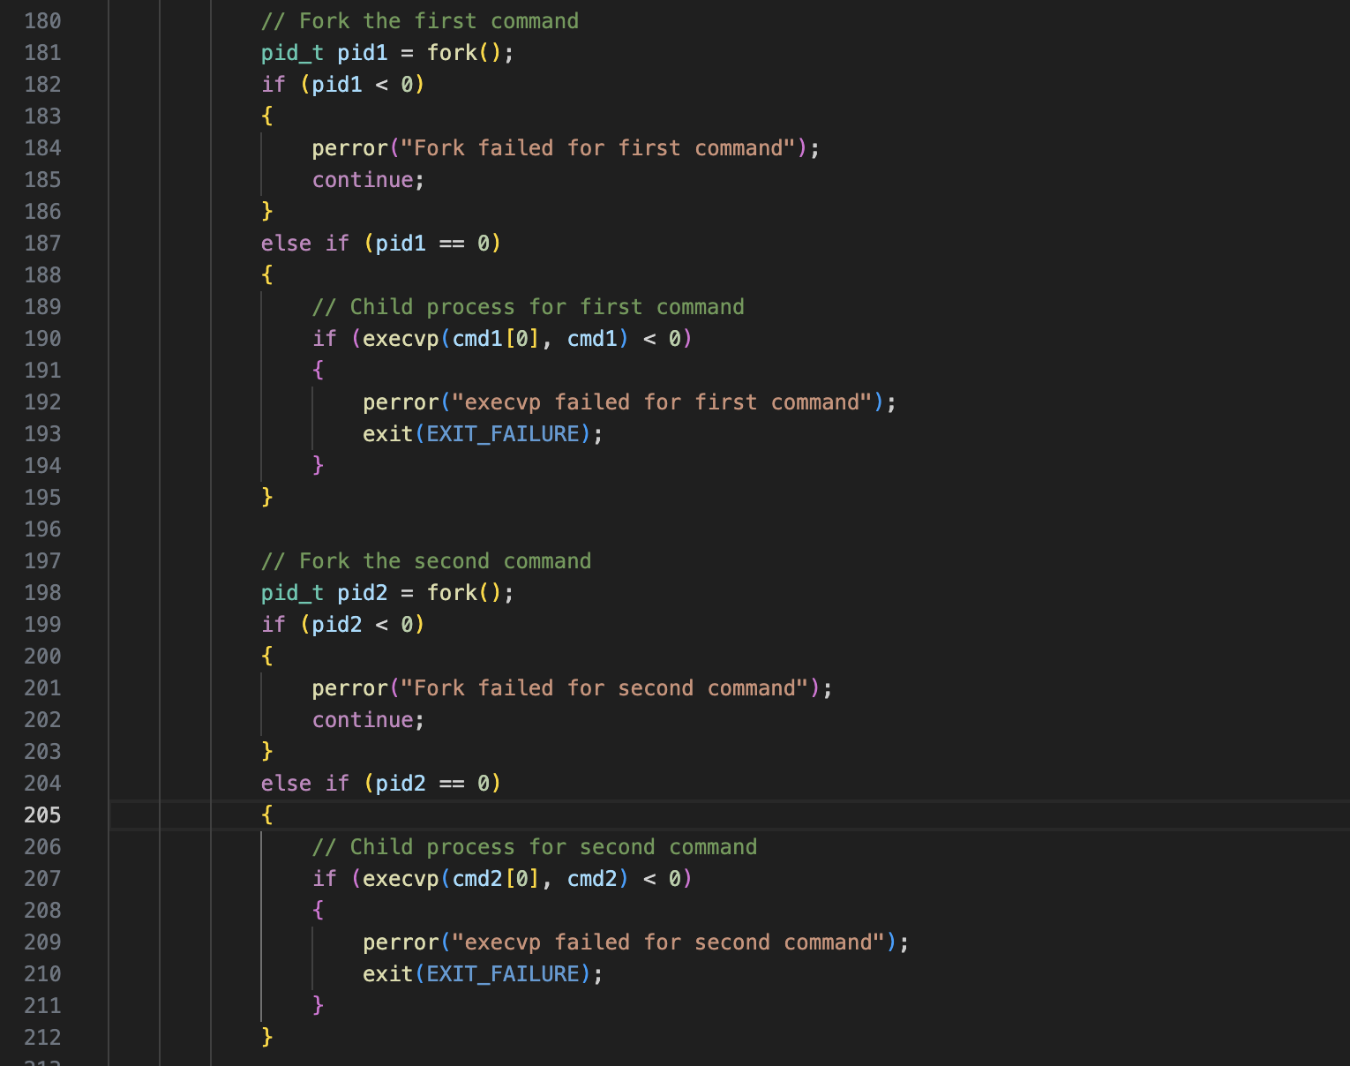

* **Forking for the First Command**:
  + A new process is created using **fork()**. If **fork()** fails, an error message is printed.
  + If the process is the child (**pid1 == 0**), it attempts to execute the first command using **execvp**. If **execvp** fails, it prints an error message and exits.
* **Forking for the Second Command:** same thing as the first command's forking logic. It creates a second child process for executing the second command.

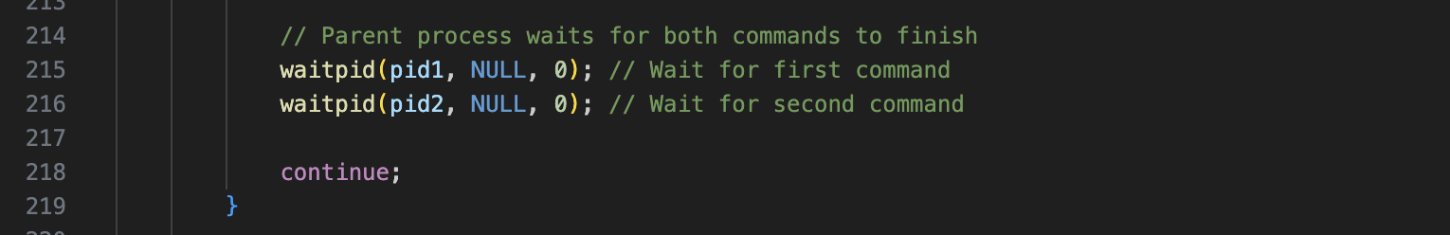

* **Waiting for Child Processes**: The parent process waits for both child processes to finish executing their respective commands using **waitpid()**. This ensures that the parent does not proceed until both commands have completed.
* **Continue Statement**: This statement ensures that if the **join** command was executed, the shell will skip any further processing and wait for the next user input.

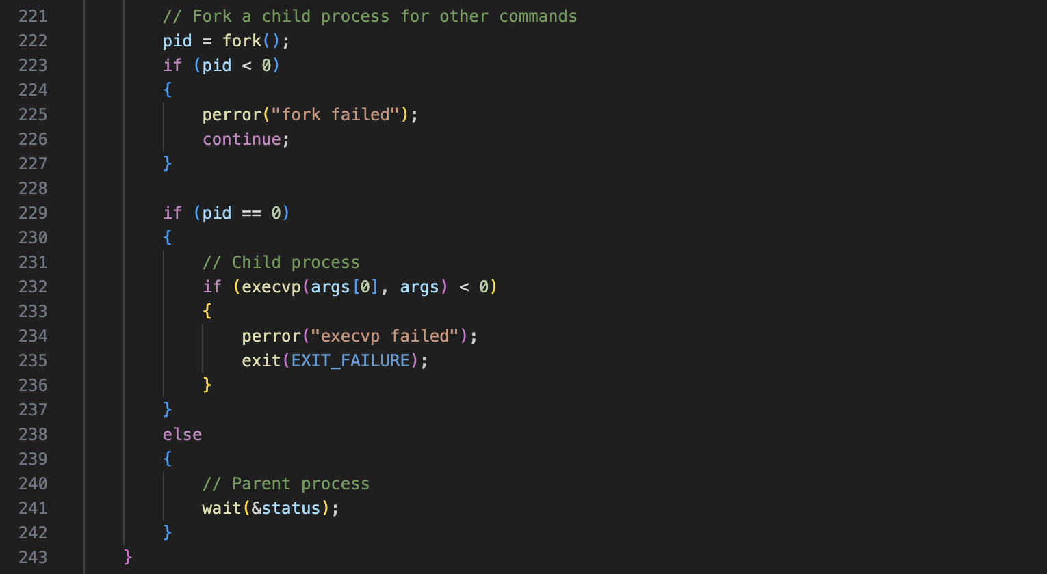

* **Handling Other Commands**: If the command is not **join**, the code forks a new child process for executing other commands.
* **Forking Logic**: similar to the other one., it checks for errors during **fork()**. If successful, the child process attempts to execute the command using **execvp**. If it fails, an error message is printed, and the child exits.
* **Parent Process Wait**: The parent process waits for the child to finish executing the command using **wait()**, ensuring proper synchronization.



1. **pthread_mutex_destroy(&history_mutex);**: This function call cleans up and frees resources associated with the **history_mutex**, which is used to synchronize access to shared data (like command history) among threads. It should only be called when the mutex is no longer needed.

**Discussion on Results**

The shell command executor was successfully implemented and tested

The results show that the shell can execute multiple commands and maintain a history without issues. The implementation of the **join** command works as intended, allowing for concurrent execution of commands.

**Conclusion**

The project successfully demonstrates the ability to create a basic shell command executor with essential features like command history and concurrent execution. Future improvements could include adding more built-in commands and enhancing user experience with better error handling and input validation.

**Keywords:**

1. **Headers**: Files included to use standard library functions and types.
   * **stdio.h**: Input/output functions.
   * **stdlib.h**: General utilities like memory allocation.
   * **unistd.h**: Unix standard functions (e.g., fork, exec).
   * **sys/types.h**: Data types used in system calls.
   * **sys/wait.h**: Macros for process termination.
   * **string.h**: String handling functions.
   * **pthread.h**: POSIX thread (threading) functions.
2. **Macros**: Constants defined for easy reference.
   * **MAX_INPUT_SIZE**: Maximum size for input strings.
   * **MAX_ARG_SIZE**: Maximum number of command arguments.
   * **MAX_HISTORY_SIZE**: Maximum number of commands to store in history.
3. **Data Types**:
   * **pthread_mutex_t**: Data type for mutex locks in threading.
   * **char**: Character data type.
   * **char \*\***: Pointer to a pointer of characters (array of strings).
   * **int**: Integer data type.
   * **pid_t**: Data type for process IDs.
4. **Functions**: Blocks of code that perform specific tasks.
   * **print_prompt()**: Displays the shell prompt.
   * **print_help()**: Lists available commands.
   * **print_history()**: Displays command history.
   * **clear_history()**: Clears the command history.
   * **run_command()**: Executes a command in a new thread.
   * **get_command()**: Reads user input.
   * **main()**: Entry point of the program.
5. **Mutex Operations**: Functions for thread synchronization.
   * **pthread_mutex_lock()**: Locks a mutex.
   * **pthread_mutex_unlock()**: Unlocks a mutex.
   * **pthread_mutex_init()**: Initializes a mutex.
   * **pthread_mutex_destroy()**: Destroys a mutex.
6. **Process Control**: Functions for managing processes.
   * **fork()**: Creates a new process.
   * **execvp()**: Executes a program with arguments.
   * **wait()**: Waits for process termination.
   * **waitpid()**: Waits for a specific process to terminate.
7. **Input Handling**: Functions for reading and processing input.
   * **fgets()**: Reads a line of input.
   * **strcspn()**: Finds the length of a substring.
   * **strtok()**: Tokenizes a string.
   * **strcpy()**: Copies a string.
8. **Control Structures**: Constructs for controlling the flow of execution.
   * **while (1)**: Infinite loop.
   * **if (condition)**: Conditional statement.
   * **else if (condition)**: Alternative conditional statement.
   * **for (initialization; condition; increment)**: Loop with initialization, condition, and increment.
9. **Error Handling**: Techniques for managing errors.
   * **perror()**: Prints a descriptive error message.
   * **exit(EXIT_FAILURE)**: Exits the program with a failure status.
10. **Commands**: Built-in commands for the shell.
    * **help**: Displays help information.
    * **ls**: Lists directory contents.
    * **ps**: Displays current processes.
    * **pwd**: Prints working directory.
    * **date**: Shows the current date and time.
    * **whoami**: Displays the current user.
    * **uname**: Shows system information.
    * **df**: Displays disk space usage.
    * **history**: Shows command history.
    * **clearhistory**: Clears the command history.
    * **join**: Combines two commands.
    * **exit**: Exits the shell.

Key Changes for the new updated version:

* ﻿﻿Added a function ***'is_supported_command'*** to check if the entered command is in the list of supported commands, if it’s not then it will return and error text saying that the command not supported.
* Before forking a child process, the program now verifies if the command is supported. If not, it informs the user and continues to the next prompt.